**ELL Case Study Report**

Amanda Barringer

CI 3000-414

Fall 2014

**Student Biography**

**Personal**

Jay is a six year old first grade Hispanic female. Her mother passed away a year ago and her father is a factory worker that struggles to support his daughter. Because of her father’s work schedule Jay does not get to spend much time with him and usually goes home from school with other families. According to her teacher the student is bullied by the children in the other families. I found this out when I gave the student a book after conducting an assessment and Jay was beyond ecstatic! The teacher told me the last time Jay had taken a book home the children of the family ripped up the book. With all of that said that student does receive counseling on occasion at the school. Jay has an older half -sister through her mother that is fourteen. This sister lives with Jay’s grandmother and it seems she gets to visit with them often. Jay appears to have a good relationship with her sister as one day she came in bragging that her sister had done her hair. Jay also has done a couple of writing journal entries about things she has done with her sister such as feeding the dogs, which is included in the appendix.

Jay’s family is from Guatemala, in Central America. According to the ESL instructor most of the students in the school are from the Huehuetenango area. Most of the families moved to America during Reagan’s presidency as they were promised work in the chicken mills in Morganton, NC. The instructor said that students from this area already speak two languages aside from English. Their village language, which Jay’s is called Kanjobal and Spanish. I am unaware of Jay’s proficiency levels in either of these languages. However, when sitting at lunch with a group of these students Jay and another student were conversing in and out of English and another language.

Jay is very outgoing when it comes to adults as she was one of the first students to welcome me to the classroom and asked me to help her. The student likes to play outside when she is not in school and her favorite game was to pretend to be princesses. Though she is outgoing with adults I noticed that the student is shy around her classmates. I went out on the playground one afternoon to talk with the teacher and Jay came up to me asking me to play. I told her she should take advantage of the time and play with her friends. She then told me that she had no friends. At the time I was not sure if she was exaggerating, but during my time in the classroom I noticed that Jay only talked to one other student on occasion. A clearer description of Jay’s social hesitation is provided in the classroom observation when Jay was given the option to work with a partner, but chose to work alone. I also noticed that she kept a good distance between her and the other students.

**Student at School**

Every morning students are to turn in their homework folders, layout their planners, and trade out their baggy books. During my time at the internship Jay brought these things in about four times. I also know that the student had about three overdue books from the school library. Jay seems to have a difficult time getting in-class assignments completed and staying on task. With regards to Jay not turning in her assignments and not staying on task one would assume she did not want to be there. However, it’s quite the opposite as the main teacher, the ESL instructor, and through my own observations Jay seems very eager to learn and still wants to please the teacher.

Having mentioned the student’s family situation her father is unable to take part in the student’s education. The ESL instructor said that people tend to misconstrue the parent’s absence in the child’s education that they do not care, however she said that most of the parent’s become distraught when they find out their children are behind. She said that all parent’s want the children to succeed, but it is especially true with ELLs that parent’s do not have the resources to help. Due to the father’s work schedule and hearing Jay talk adoringly about her father this would appear to be true in Jay’s case.

The student is an ELL and has been assessed by the school using the WIDA scaling. Jay had an overall rating of 1.7 or in the late stages of the entering level. Jay’s listening and English speaking skills are in the emerging stage and are more developed than her reading and writing skills which fall within the entering stage. There were a few instances where the student did not understand what I was asking her such as when I asked what she did over the weekend. Jay just looked at me very puzzled and asked what did you while you were out of school. She still never answered changing the topic. The student also showed signs of confusion when I was giving her directions while working on a math turkey.

ELLs face many challenges in school such as mentioned by Peregoy and Boyle, “Socioeconomic status has proven to be one of the strongest predictors of standardized test performance. Children from low-income families consistently score lower” (p23). In line with this quote Jay is behind her peers academically even though she is in a very diverse class with over half being ELLs. In the math interview I conducted I realized the student had no concept of subtraction which is a Kindergarten standard (Student completed kindergarten at this same school). However, Jay did show familiarity with addition even if she still did not show any ability to correctly compute a sum. In reading the student does have a basic knowledge of concepts about print and appears to be in the late stages of emergent literacy as I concluded in the Reading Assessment found in Appendix B. The school uses the program STARS assessment to monitor student progress throughout the year. Having viewed Jay’s scores on this assessment compared to grade level and peers she is way below in reading. Having analyzed a piece of the student’s writing I rated the student as having an entering level writing ability, which can be confirmed through the student’s WIDA writing score of 1.6 (late stages of entering level). In my teacher interview the teacher believed that Jay’s strongest subject was reading and weakest was writing. However, her WIDA scores suggest the opposite that her writing (1.6) is just a little bit better than her reading (1.4). Based on the aforementioned data the student’s strongest subject appears to be reading based on WIDA scores and the student’s excitement when given a book. Then her weakest subject would be math since she is unfamiliar with terminology and concepts. When I asked the main teacher what her goals were for Jay was she said that she wanted Jay to be on grade level in all subjects.

The school Jay attends uses a pull-out program to provide additional aid for English language learners. Jay attends this program five days a week for thirty minutes each session. This time falls during math instruction which may be a factor in Jay’s lower math scores. I know that in this program the instructors utilize the picture word inductive model as I have seen the students come back and show me their labeled images. The image I remember most was a black and white image of the school entrance and each student had different labels.

The rest of the Jay’s education takes place in the regular school setting. The teacher in this classroom said that the student worked best in a one-on-one setting as seen in the teacher interview. It is also listed as a modification for the student’s action plan. All of the students are to read one-on-one with the teacher’s assistant or other aids including myself each school day. Then when the students were working on writing journal assignments or projects that require many steps I would work with a small group of students that included Jay. However, I was only there once or twice a week, so what help these students received when I was not there I do not know. The teacher has a wide range of book levels in the classroom for students to pick-out for their baggy books. Once during reading groups the teacher utilized a virtual book that also provided Spanish translations. It was awesome to see the students eyes light up when the teacher started playing it! There is a word wall on the wall in the back of the classroom, however, in my time there I did not see it used. For writing assignments the teacher always had a starter sentence for the students to use. When I first started attending it was a complete sentence for the students to copy. The teacher slowly lessened the amount of scaffolding to where my last day they were fill- in- the- blank sentence starters.

Within the main classroom an important observation to note is that on several occasions the teacher told students that Spanish is not academic speech and they needed to use English. This is not a school policy as I witnessed kindergarten and other first grade teachers using Spanish with their students. Nor were any cultures represented in the classroom or the school. However, it is a school wide policy for each grade level to divide students into separate reading groups and attend a different class for thirty minutes a day. It was within this reading group classroom that I conducted my formal classroom observation. This teacher provided many instructional modifications utilizing every type of grouping, providing multiple forms of comprehensible input, and use of realia. For more specific examples view the Classroom Observation in appendix B. This reading group consists of students in the lower reading level all but two were ELL. During the lesson I observed students were reviewing site words by going on a word hunt. Jay kept to herself most of the time appearing interested and focused on the task. When students were to break into groups to work on site word puzzles Jay was very hesitant at first, but eventually warmed up smiling and laughing while working.

**Recommendations**

My first recommendation would be in regards to the classroom environment and making it more welcoming to the vast number of Hispanic students. Peregoy and Boyle recommend, after first creating an environment that students can feel safe and secure in, for teachers to create a sense of belonging (p20). Incorporating cultural decorations, stories, and traditions in the classroom can help create an environment that students can connect to. I believe it was Chomsky who said that language is the key stone to culture. With that said I do not agree with the teaching practice of not allowing ELLs to use their home language at school. Though it is important for students to practice English I do not agree with disregarding their home language because there are many benefits to building a student’s L1 such as identity with culture and creating a foundation for transfer into L2 development (Peregoy & Boyle, 2012, p73).

Another recommendation for the classroom includes collaborative or cooperative settings in instruction and for projects. “At the beginner level, support for participation in lessons comes from three sources: the teacher, other students, and the newcomers themselves” (Peregoy & Boyle, 2012, p.139). In other words allowing students to work with classmates can be used as a scaffold. This is especially useful for ELLs as they may not fully comprehend instructions and by having another student with them who knows what is going on can help them stay on task. I realize that Jay’s class has a disproportionate ratio of ELLs and native speakers that could make this difficult. However, this is not the only benefit. I noted several observations of Jay being hesitant with socializing with peers (class observation and profile sheet). This could be caused by the bullying noted by the teacher, communication issues, or other happenings. Either way creating a positive environment for socialization, even if it is for academic purposes, and a means to connect with peers could increase Jay’s comfort level in social settings.

As previously stated Jay’s weakest subject is math. After analyzing my math interview I gave the following suggestions; discourse (to discuss as a class methods of solving a given problem), attend kindergarten math lessons, and provide number organization strategies. For more in depth descriptions why these recommendations were made see Math Interview in Appendix B. Upon further reflection another recommendation would be to intentionally provide word study of math vocabulary and symbols in order to help Jay be more familiar with the terms. As these terms can be used during discourse and benefit further understanding of math concepts. It is also recommended not only for ELLs, but for younger students in general to utilize manipulatives as much as possible. This is helpful as most young students do not have the capacity, usually due to dexterity, to write neatly enough that equations can be comprehended. Therefore, by using the manipulatives students are able to concentrate on the math concept and not writing skills.

Based on my observations I concluded that the student appears to get adequate reading instruction with the reading group teacher focusing on site words and the main classroom having access to many emergent level text and opportunities to read. Other recommendations for emergent readers include choral reading and picture walks to provide extra reading support. Also, after seeing the expressions on the student’s faces when hearing a story read in Spanish it should be used more frequently. As an ELL Jay would greatly benefit from a word study through word sorts as they provide visuals, repetition, and is a quick word study lesson. Based on the Reading Assessment, the student should start with a short vowel word sort. This will help the student gain full phoneme segmentation and could also be used to increase vocabulary. When writing journal responses the amount is usually limited to what the teacher has provided. Allowing Jay to draw the story or event, label what is happening and then write sentences creates a scaffold to where the student has more details to write about resulting in a more in depth writing sample.

**References**

Peregoy, S., & Boyle, O. (2012). *Peregoy and Boyle. Reading, Writing, and Learning in ESL: a Resource book for teaching K-12 English Learners.* Pearson.

**APPENDIX A: Student Data**

**Case Study Profile Sheet**

|  |  |  |  |
| --- | --- | --- | --- |
| **Name: #####** | **Age:** 1st grade | **Country of origin:**  Guatemala |  |
| **Linguistic & Cultural Background** | **School experience** | **Literacy L1** | **Literacy L2** |
| Ask Student:   * What do you like to do at home?   Play outside. Pretend Princess.   * What did you/are you going to do this weekend?   Student did not understand the question. | Observe:   * How often they participate   Quiet   * Do they turn in assignments?   Only once or twice in the 12 days I was there.   * Do they stay on task?   Not unless someone is working one-on-one with her.   * Do they seem happy?   Yes | Spoke another language during lunch with another student. Switch between that language and English. | Reading Assessment for Emergent Readers  See Appendix B |
| **Assessment Data** | **Family info** | **Learning styles** | **Strengths/interests** |
| WIDA ACCESS scores: Overall- 1.7  Listening- 2.6  Speaking- 2.4  Reading- 1.4  Writing- 1.6 | Ask Student   * Do you have any brothers or sisters?   Older half- sister age 14, lives with her grandmother. | Ask Teacher:  What social setting do they work best in?  One-on-one  Which modality helps the child learn?  visual | Ask Teacher:   * Which do you think is the student’s strongest subject area?   Reading  Weakest- writing   * What goals do you have for this student?   To be on grade level in all subjects. |
| **Other Comments:**  On playground told me she had no friends.  Teacher- book bullying incident. | | | |

**Written Language Sample, Notes and Analysis**

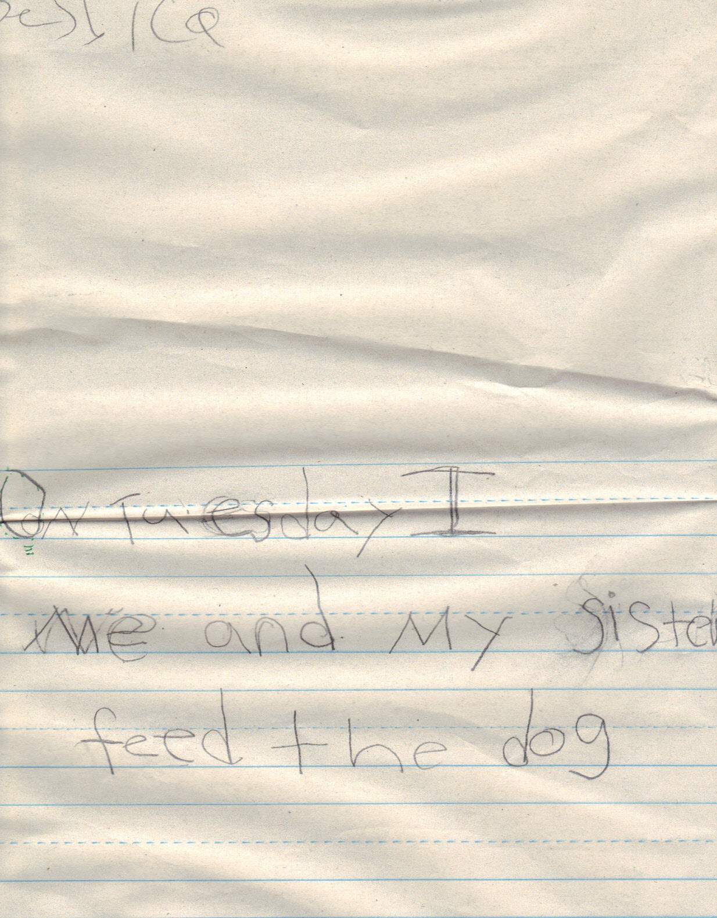

**Context**- The writing sample was a class journal entry. The teacher verbally said that the prompt was to write about what they did over the weekend. The teacher also provided the starter sentence, “On ________I _________.” Later she wrote on the board how to spell Friday, Saturday, and Sunday. The student also asked me how to spell sister. The students were given twenty minutes to do this along with drawing an illustration of what they wrote. It also looks like the teacher created a stencil for the student to capitalize the O at the beginning of the sentence.

|  |  |  |
| --- | --- | --- |
| **Student:** | Specific Examples | Rating |
| Linguistic complexity: | A single thought is represented: that she and her sister fed the dogs. Basic sentence structure that the student used was provided through starter sentence by the teacher. | 1 |
| Vocabulary Usage: | General everyday words were used Tuesday, sister, and dog. | 1 |
| Language Control | Student seemed unsure of whether to refer to herself as I or me. Student used the word feed instead of the past tense fed. | 1 |

**Overall Level: 1**

**Analysis and Rationale:**

The writing sample is very short given the amount of time and scaffolding that was provided for the student, which to me is an indicator that the student is within the beginning stages. Seeing as the student did not write beyond the starter sentence I am led to believe that she may not have the ability to create another simple sentence structure and that is why I rated linguistic complexity as entering. It is hard to gauge vocabulary from one sentence, but the words used were common everyday words which matches the description of vocabulary for an entering level student. The student seems unfamiliar with grammatical rules such as verb tense and whether to refer to herself as I or me in the sentence. Though confusing I and me is usually a common mistake amongst first graders most of them do have an idea of verb tense. Therefore, I concluded that the student’s language control was also entering level. With all three categories being within the entering stage it is only fitting to conclude that the student has an overall entering level writing ability.

**APPENDIX B: Classroom Data**

**Teacher Interview**

1. What social setting do you think the student works best in group, one-on-one, etc.?

One-on-one

1. From your observations which modality do you think helps the student learn; auditory, kinesthetic, visual, or tactile?

Visually

1. Which subject do you think is the student’s strongest and weakest?

Strongest would be reading and the weakest is writing.

1. How would you describe this child as a student?

She is very hard working and eager to please.

1. What goals do you have for this student?

To be on grade level in all subjects when she leaves.

1. How involved are the parents?

Her mother passed away and the father is constantly working to provide for them. She never goes home after school because her father is working. She normally stays with another family where those kids bully her according to the teacher.

**Classroom Observation**

On November 4 I went with my first grade case study student to her reading comprehension group. At the beginning of the year all of the first graders were given a reading assessment and divided into reading groups based on their scores. The group my case student was in was the below grade level group. There were at least twenty students in the group and the majority were English Language Learners. The lesson I observed was about forty minutes long and was a review of the cite words the students had previously been working on.

The reading comprehension group meets in a classroom that is a mobile learning center, which was more spacious than I had expected it to be. The teacher had several types of groupings throughout the lesson. The teacher started students off in a circle on the carpet while she gave instructions. Students were then to do the activity, which was a scavenger hunt of site words that required them to walk around the entire classroom. She also gave them the option of working with a partner, however, my case student did not nor had I noticed any of the other students doing this. Once the students had all of their words written down they were to get in line and read the words out loud to the teacher in a one-on-one session. When this activity was completed the students divided themselves into two groups, male and female, to work on site word puzzles. In reflection the teacher masterfully included every form of group instruction.

Since the majority of students in the reading comprehension group were English Language Learners the teacher seemed to have several techniques when she provided instruction and feedback. During instruction when the teacher was giving directions on what students were to do I noticed her speech slowed and she enunciated more than she had in casual conversation. The teacher also modeled the activity students were to do by walking around the classroom and writing down words. Then the teacher role played saying the word out loud to herself. When giving feedback I observed the teacher using hand gestures when a student was having trouble reading the word ‘down’ and she pointed her finger down asking the student what she was doing. These things allowed for more comprehensible input.

The teacher definitely seemed to have catered to her ELL students as I noticed lots of scaffolding and other instructional modifications. The main indication that the teacher was catering to ELL’s is that she hit three of the four WIDA subject areas: reading, writing, and speaking. The teacher provided lots of scaffolding by using the worksheet, demonstrating what they were supposed to do, allowing them to work with a partner, as well as incorporating several grouping styles. Not only did the teacher provide directional instruction, but she also went over strategies with students on what they were to do if they got stuck. Such strategies included asking a classmate, asking a teacher, or skipping it and coming back to it. I also think that by dividing the students into those reading groups is an instructional modifications because this puts students on the same level in the same class allowing the teacher to provide for specific needs.

Specific observations of my case study student revealed a shy side to her that I had not seen before. As mentioned before students were given the option to work in pairs and this student chose not to as did many of her classmates. However, I noticed that as the students walked around the case student was never really around her classmates. She did not talk with peers when they were in the same area. I assumed this to be a positive trait thinking she was staying focused on her work and yet she was one of the last to finish. When students were split into two groups the student seemed to be happy in the group smiling and participating working close with one particular student. I noticed the case student consistently sought the teacher’s approval showing her work to her and the other intern in the room. The student was all smiles then and seemed to gain a lot of satisfaction from the teacher’s response.

**Math Interview**

Description of Interview Process

Three interviews were conducted one student for each of the following math levels as classified by the teacher; low, medium, and high. The interviews were conducted to assess the student’s understanding of subtraction, math level, and other important math concepts. Each interview was conducted individually in the back of the main classroom. Jay was interviewed as the low level student.

At the end of the interview the student was asked to write a word problem. Student wrote the following:

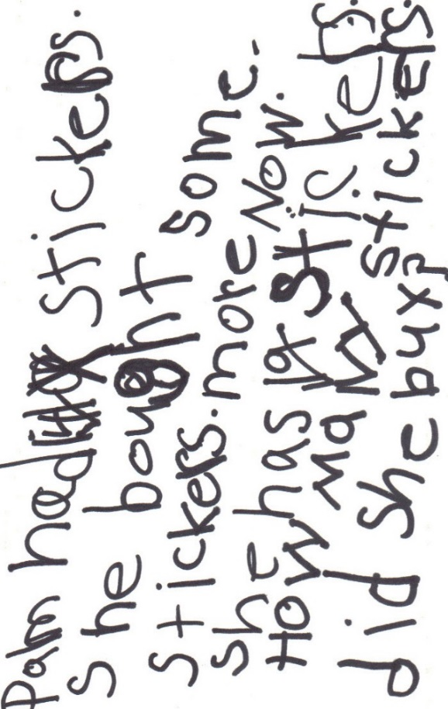

Analysis of Student’s Response

It was not until we got to the written equations part of the interview that I realized the student had no concept at all of subtraction. If you look at the transcript I asked the student what (-) meant and responded, “No, can we do this instead?” Subtraction is part of the Kindergarten standards, but most likely due to English proficiency it would appear the student did not obtain this knowledge. The student added in every single problem presented. Looking at accuracy if they were intended to be addition the two she did correctly were the equations and she did not use the stickers. However, 13+5=18 is correct when I asked how she got it she pointed at the index cards we had previously used and 18 was the first number. Therefore, I would conclude that the student does not have a complete understanding of addition either. The student does seem to know that number symbols represent a quantity.

Comparison to Other Students

Compared to the other two students interviewed this student seemed to have no understanding of subtraction. This student did not appear to have an understanding of addition either whereas the other two students did. This student is definitely at a very basic level of math concepts in general not just of subtraction. I did give similar teaching strategies for the medium level and this student since both are English language learners and I found the same interviewing biases when analyzing the transcripts.

Implications for Teaching

The student needs lots of remedial work particularly in basic math computation. Jay could possibly benefit from attending a kindergarten math lesson for a certain period of time per day or week. The grade gap is not large meaning that Jay will be close in age versus if the student was older with a larger learning gap. Providing the student with strategies to organize numbers would also be beneficial. Consider giving the student a piece of paper that separates the numbers in an appropriate way to start out with. Strategies for breaking down word problems by sentence, seeing as I had to do that for her. It would be great if she learned to do that on her own. As mentioned in implications for other English language learner any chance for student to build and use language is a major plus making discourse extremely valuable for these students. The realization that I might have students on this level in my class, I am sure they are even in second and third grade, that I have to teach this content to scares me.

I know that dividing classes into small groups for reading is common in classrooms due to the huge gaps in reading levels and abilities. This interview compared to the previous two really gave me insight to the huge gaps that can occur in math levels and abilities among students. It could be beneficial to also divide students into small groups for math instruction as well to better cater to student’s abilities.

**Reading Assessment for Emergent Reader**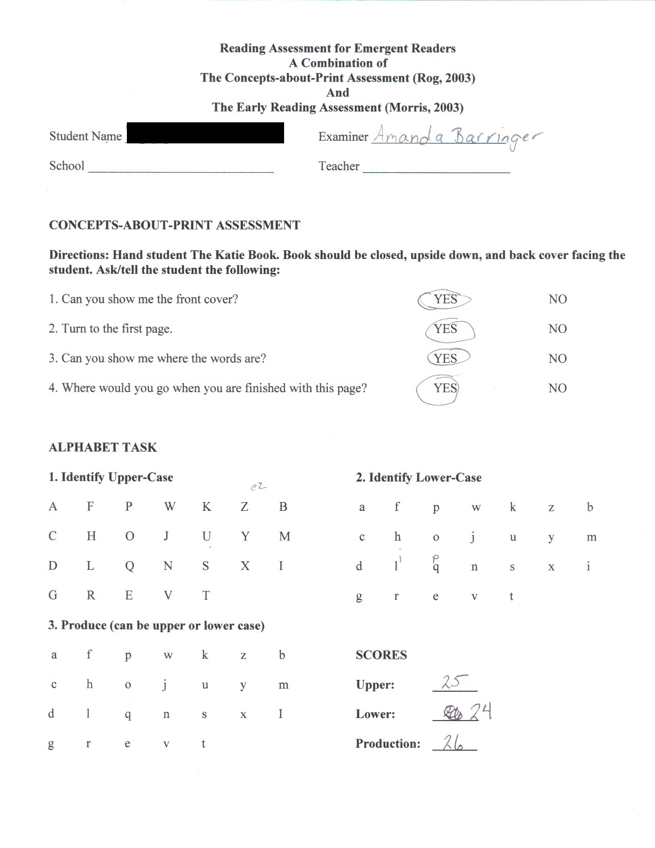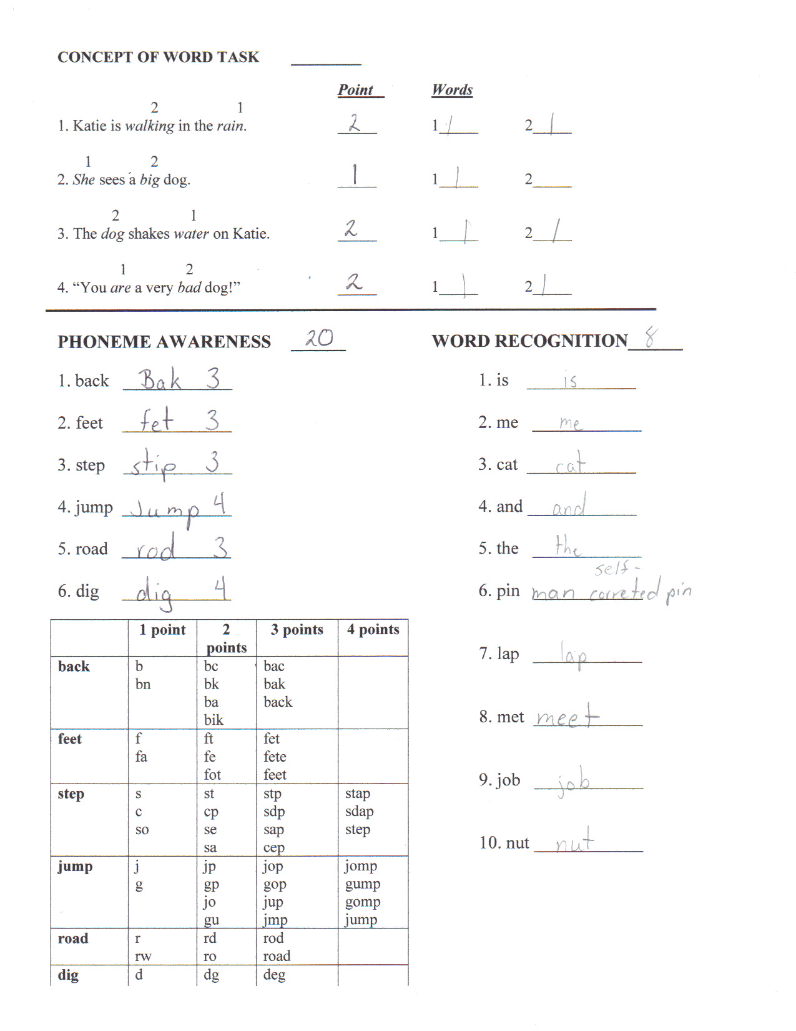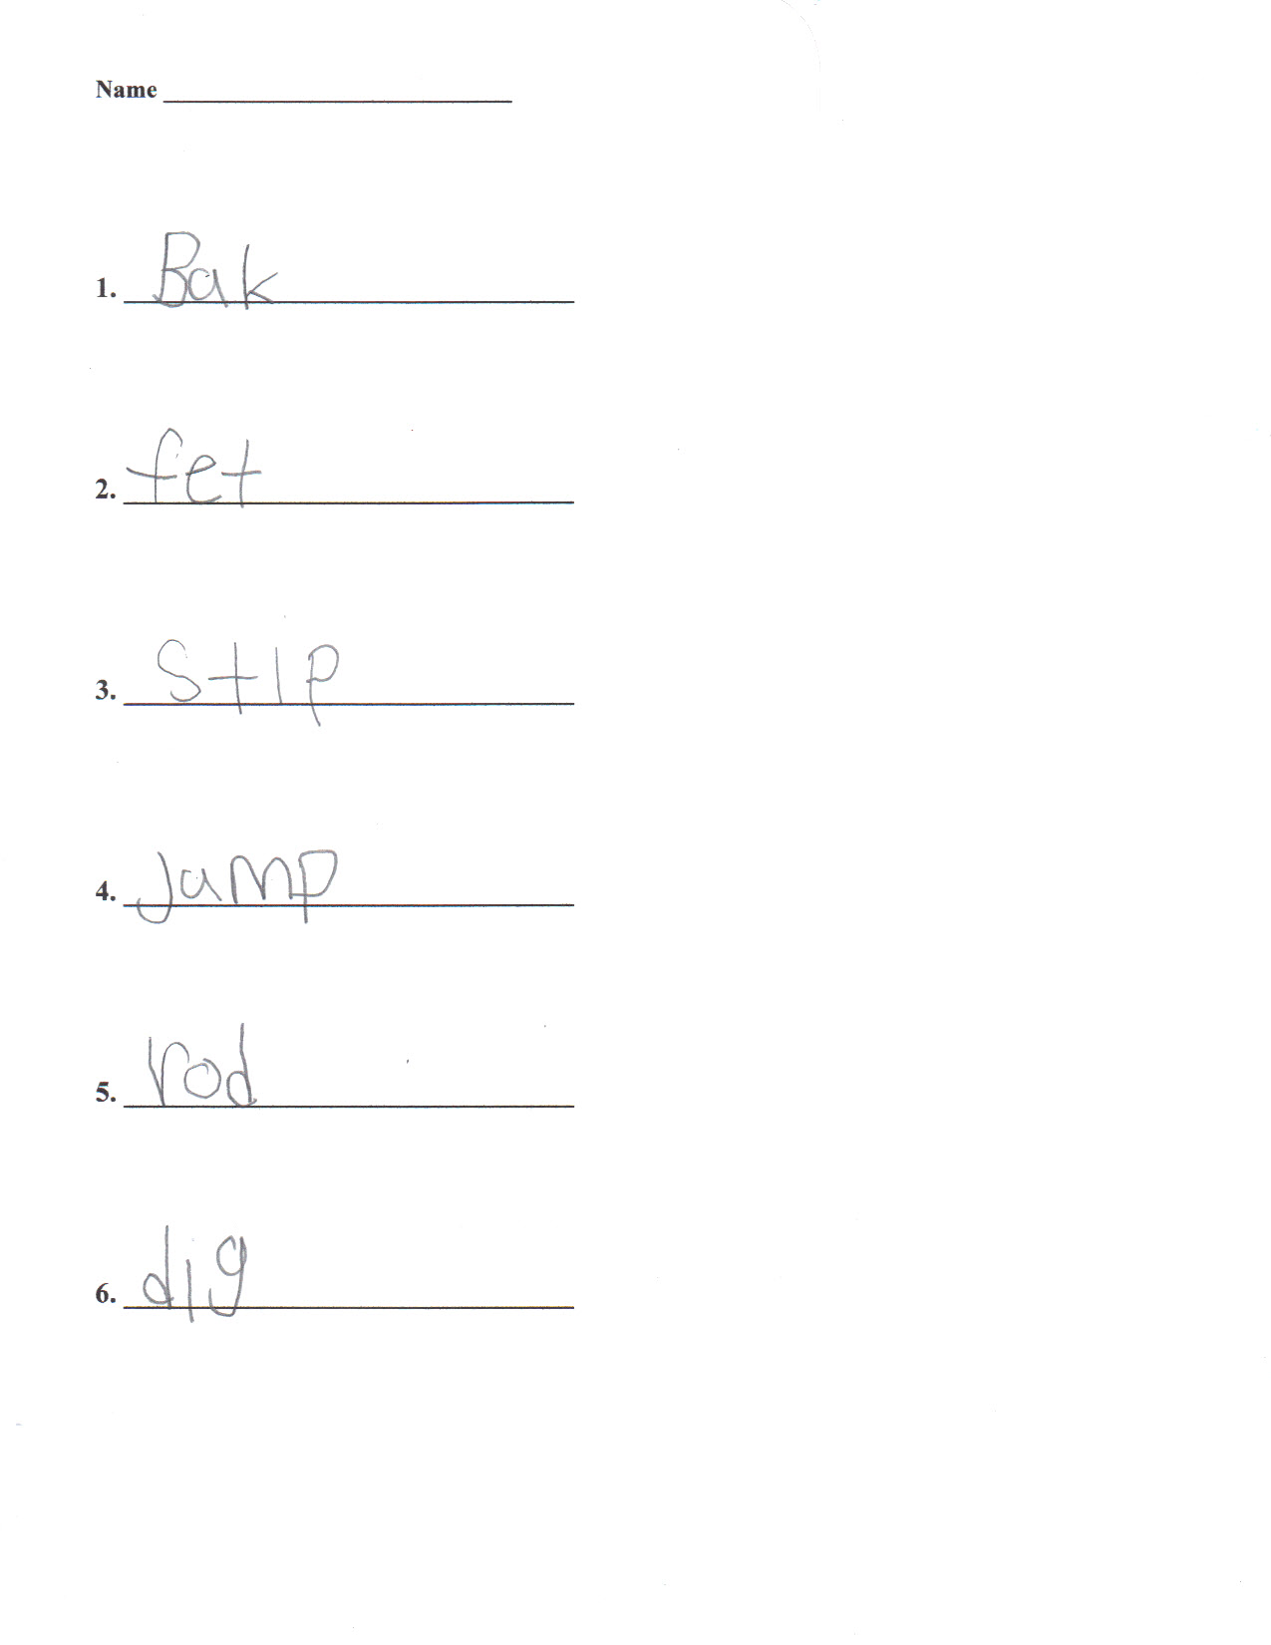 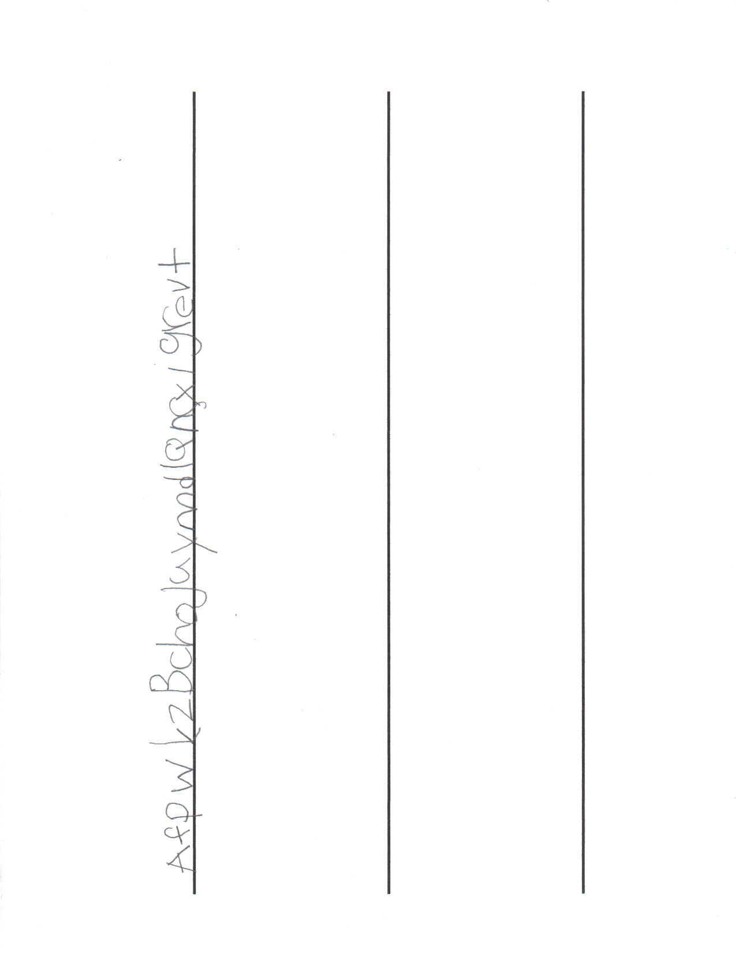

Analysis

Based on the assessment the student has mastered concepts-about- print correctly pointing out the majority of words. Within the alphabet task the student said ez for capital Z, which is understandable based on Hispanic background. The student also misread the lower case letters as i for l and p for q. These errors could be considered common errors for this grade level. The student was able to correctly write all of the letters spoken. She is in the final stages of phonemic awareness having initial and final consonant awareness along with medial short vowels. The student recognized eight of the ten words shown self-correcting one of them. Based on this data the student is in the late stages of the emergent reader level.