Spelling Assessment

Completed: November 24, 2014

Student: Kyle

*(Student's real name not used)*

Grade: 1st

Examiner: Amanda Barringer

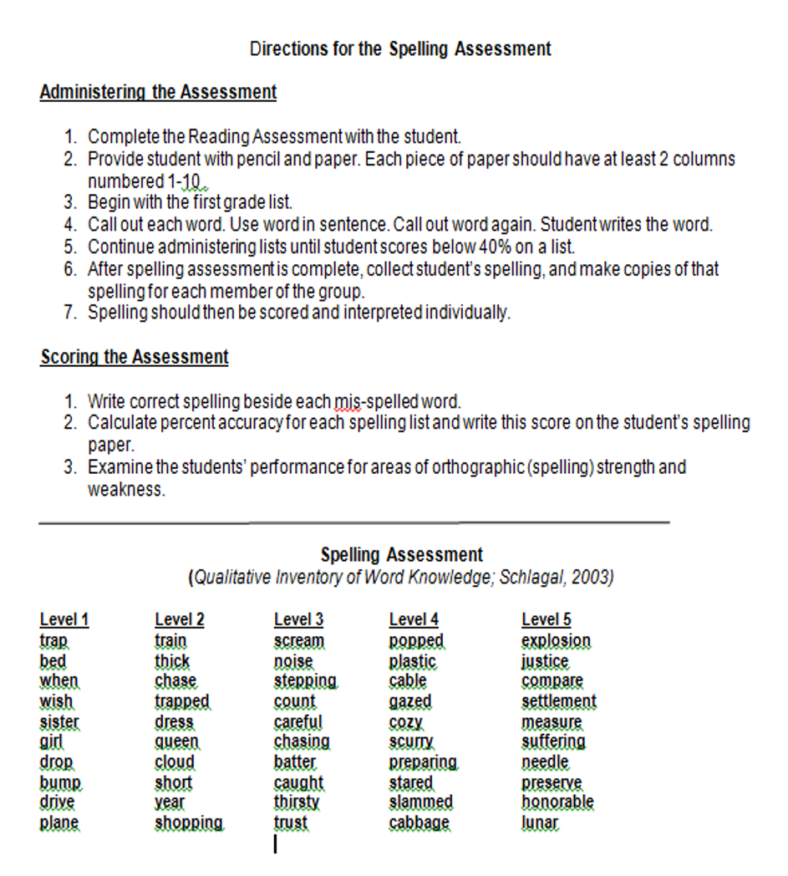

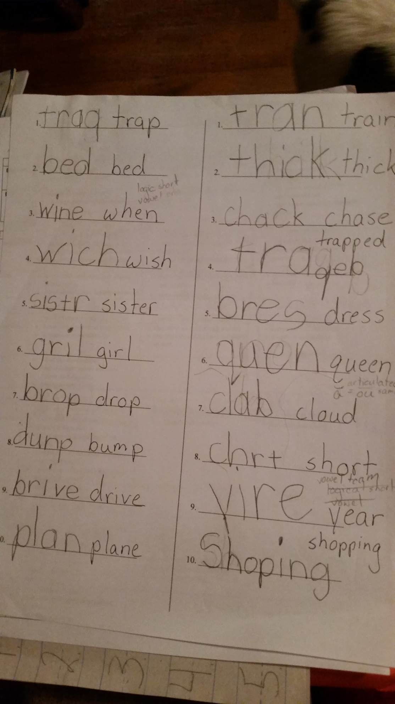

**Spelling Assessment**

**Administered November 17, 2014**

**Stage of Spelling Development:**

**Late Letter-Name Stage**

**Justification of Stage**

**What is the student doing correctly:**

Kyle is using the correct initial sound correspondent. Even though the student had b’s and d’s written backwards (spelling ded for bed and brive for drive) I excluded this because the student also wrote several p’s backwards when writing trap and trapped. Therefore, I concluded that the backwards letters were writing mistakes not sound correspondent mistakes. Kyle had most of the correct final sound correspondence except when spelling chase (student: chack). The student had a vowel in each syllable except those controlled by r (sistr for sister and chrt for short).

**What is the student “using but confusing”:**

Kyle was aware of initial blends and digraphs, however they were not always the correct ones. Kyle seems to have the majority of blends and digraphs when they are at the beginning of a word. The student correctly spelled thick, but then applied ck when trying to spell chase. Kyle showed the same trend with the digraphs ch and sh (Writing wich for wish and chrt for short), but used them correctly when spelling chase and shopping. The student correctly used a silent-e for drive, however did not use it at all for plane and used it to spell year (student wrote yire) as well as spelling the word when (student wrote wine).

**Appropriate Level of Spelling Instruction:**

**Short Vowel Sorts with Blends and Digraphs**

**glad**

**thrill**

**crash**

**quit**

**chop**

**swim**

**Justification of Sort**

**that**

**trip**

**track**

**slick**

**clock**

**shop**

**pond**

**drop**

**clap**

A student that is in the beginning of the late-letter name stage has initial and final consonant awareness and a vowel represented in most syllables. This is congruent with my conclusions drawn about Kyle’s abilities. The sort associated with developing from this stage would be the short vowel sorts. A student at the end of the stage would have blends and digraphs, preconsonant nasals, as well as regular short vowel patterns. Kyle did have most short vowels, however, he has not mastered all blends and digraphs. This is why I moved the student forward in the sort starting him with the short vowel sorts with blends and digraphs in hopes that he begins to recognize when to use them.

**Day 1**

**Instructional Activity**

**1. Sort**

|  |  |  |
| --- | --- | --- |
| **clap** | **swim** | **chop** |
| **crash** | **quit** | **clock** |
| **glad** | **thrill** | **drop** |
| **that** | **trip** | **pond** |
| **track** | **slick** | **shop** |

**2. Concentration**

**3. Spell Check**

**Observations:**

This session took a lot longer than expected around 45 minutes to complete. I had a very difficult time getting Kyle to stay concentrated and later found out that he has been diagnosed as ADD. Kyle had trouble reading words that had more than one blend or diagraph such as clock, slick, crash, and track. He was constantly looking and waiting for me to tell him the word, but I reluctantly resisted. I should have discussed the commonality of the words once the sort was complete, however, I did not and Kyle was confused as to what counted as a match during concentration. It looks like Kyle misspelled many words however the ones he rewrote were due to backwards letters not misspellings. Kyle was able to spell all but one of the words correctly! (He wrote thrll for thrill). However, no matter how I tried he insisted that he did not do well.

**Spell Check from Day 1**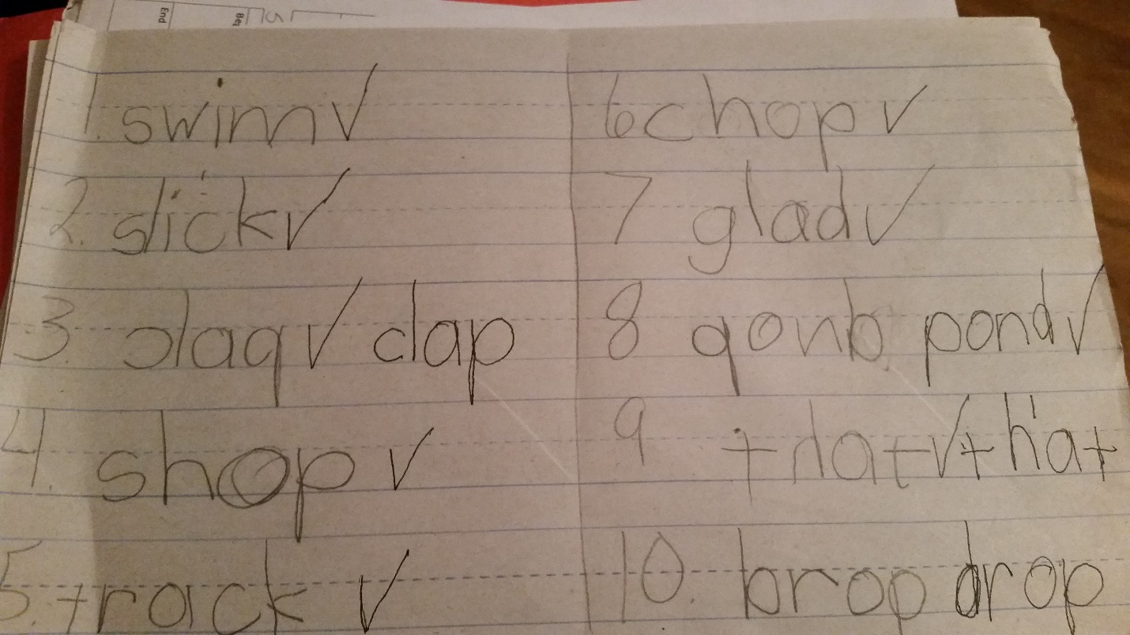

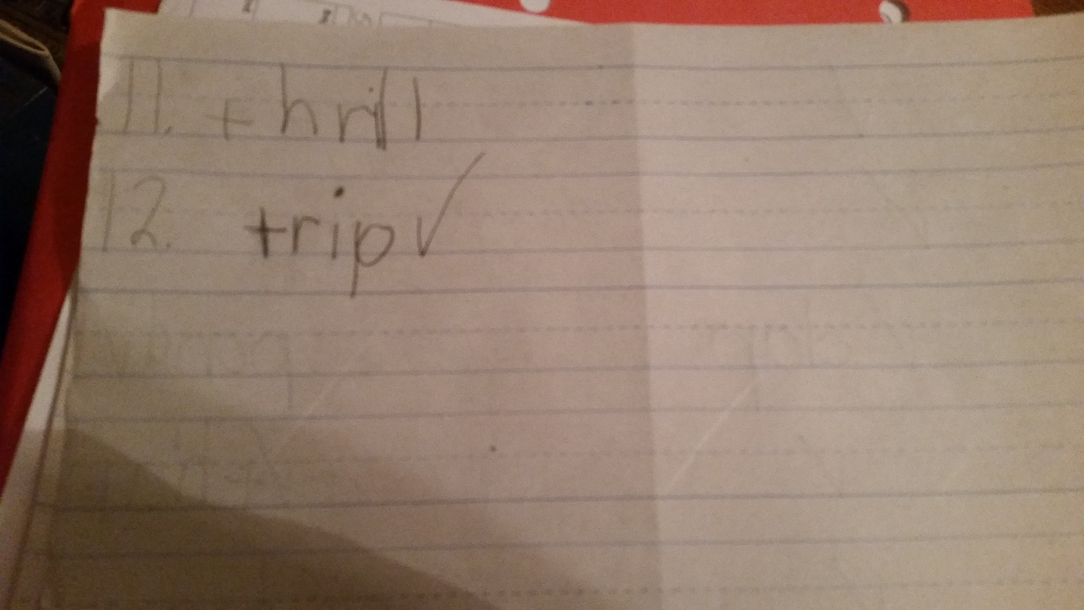

**Day 2**

**Instructional Activity**

**1. Sort**

|  |  |  |
| --- | --- | --- |
| **clap** | **swim** | **chop** |
| **crash** | **quit** | **clock** |
| **glad** | **thrill** | **drop** |
| **that** | **trip** | **pond** |
| **track** | **slick** | **shop** |

**2. Concentration**

**3. Spell Check**

**Observations:**

Having done the process before I was able to keep it fast paced keeping Kyle more involved and completing all three steps in less than thirty minutes. I used the same sort as last time and it was a week after the first day, so I remodeled how to do the word sort. This time after the sort was complete I asked what the words in each column had in common. After reading them through a couple more times he soon realized the vowels were the same. Concentration went a lot smoother and he won. I wanted Kyle to notice that his letters were backwards, so when checking the spelling words I had him read what he had written on his paper first and then the card. After the first few he started noticing the letters before he saw the card. There were a few misspellings this time as he wrote cope for chop and crach for crash. He had written those words correctly in the first spell check. Although, his teacher introduced the digraph ch the week before, which may account for the misspelling of crash. If you compare the two spell checks on the first he wrote six letters backwards and on the second spell check only three letters were written backwards.

**Spell Check from Day 2**