Media Analysis and Evaluation Template for the Website
A: Name(s) of Presenters and Curriculum Area(s) or Specialization(s)
Amanda Barringer
Trey Tillary
Elementary Education: 4th Grade Science
We will be analyzing the scene “How Bad Can I Be” from the movie, The Lorax. The movie and the clip have strong implications toward environmental issues such as air pollution and deforestation. Through media analysis and research students will learn how these issues affect them and the world we live in, in turn their new knowledge will be beneficial to the environment. This will cover content in the 4th Grade science ecosystems (4.L.1.1) and technology sources of information (4.SI.1.1).

B: Curriculum Area Standards
North Carolina Essential Standards. Science-Ecosystems. Grade 4.
4.L.1 understand the effects of environment changes, adaptions and behaviors that enable animals (including humans) to survive to changing habitats.
4.L.1.1 Give examples of changes in an organism’s environment that are beneficial to it and some that are harmful.
4.L.1.2 Explain how animals meet their needs by using behaviors in response to information received from the environment.
4.L.1.3 Explain how humans can adapt their behavior to live in changing habitats (e.g. recycling wastes, establishing rain gardens, planting trees and shrubs to prevent flooding and erosion).
4.L.1.4 Explain how differences among animals of the same population sometimes give individuals an advantage in surviving and reproducing in changing habitats.
North Carolina Essential Standards. Science. Ecosystems. Grade 4. Standard 4.L.1.1.
http://www.dpi.state.nc.us/docs/acre/standards/new-standards/science/3-5.pdf
Through a media analysis of the clip “How Bad Can I Be” students will see how much thought goes into making a movie and the influence it holds. Such, as in this clip the implications of how humans have affected the Earth’s environment. The video shows the basic concepts of what causes pollution, what it is and its consequences. After analyzing the video students will research these issues to illustrate the importance it plays in real life situations. By doing this the students are learning harmful changes to the environment (covering the 4.L.1.1 standard) and its prevention.

C: Information and Technology Standards
North Carolina Essential Standards. Information and Technology- Sources of Information. Grade 4
4.SI. 1 Apply criteria to determine appropriate information resources for specific topics and purposes.
4.SI.1.1 Use various types of resources to gather information (including print and online media)
4.SI.1.2 Use relevant sources of information for an assigned task.
4.SI.1.3 Use reliable sources of information.
North Carolina Essential Standards. Information and Technology. Sources of Information. Grade 4. 4.SI.1.1.
http://www.dpi.state.nc.us/docs/acre/standards/new-standards/info-technology/gradek.pdf
Students will view books and website that I provide meeting the (4.SI.1.1) standard. (Teacher should acquire media in advance to make sure all areas are covered and content is presented on student’s level of reading and comprehension. The content the sources should present are on environmental issues; what it is, what causes it, and how it is prevented.) Students will record their findings on a chart.

D: Media and Materials
- This video clip “How Bad Can I Be” from the movie, The Lorax.
http://www.youtube.com/watch?v=KOAETOdo2c0

- For class presentation show from 17secs. To 1:50

- Materials needed for video clip: computer and internet access
Materials needed for production piece: books, websites, internet access, markers, & poster board

E: Media Analysis and Evaluation
(The following questions will be discussed by students in small group. I want them to be in small groups so they feel more comfortable in giving their thoughts and questioning peers. The teacher should spend a period of time sitting in on each group to make sure they are participating.)
Concept 6: The media have aesthetic qualities- questions about the song
What is the tone of the song? / How does it make you feel?
The song is kind of whatever, happy go lucky beat.
-Previous answer is more from the Oncler’s view, how would the animals view the song?
Sort of snooty and condescending.
Considering some of the lyrics of the song what is the main character’s goal?
He says, “biggering my company, biggering my factory, biggering my corporate size.”
So, the success of his business which leads to money.
How do the lyrics of the Oncler’s song compare to what is happening in the video?
The more success he gets the less the animals have.
For the animals how bad does it get? And why is that bad?
They lose their home and food supply. Three basic needs to survive are food, shelter, and water, the Oncler pollutes all of it so they cannot survive.
So, is the Oncler really that bad?
Yes, he self- serving and not considering that what he does is affecting others. In doing this he has destroyed everything eventually leading to his own down fall.
F: Possible Production Connection
Divide class into 3 groups and have three stations each labeled as one of the following; Air pollution, water pollution, and deforestation.
At each work station have magazines (Wildlife)/local newspaper clippings, a few books, and/or pre-set websites that have to do with either air pollution, water pollution, or deforestation. By using these varieties of resources it satisfy the North Carolina Essential Standards Information and Technology Sources of Information 4.SI.1.1. (Encourage the group to divide up the resources among each student, to save time and prevent them from only using one resource for the chart.)
Have students read and contemplate the resources. The content of the sources are on negative environmental changes humans have caused satisfying the North Carolina Essential Standards for Science-ecosystems 4.L.1.1.
As a group have the students come together with information from their resource and create a chart.

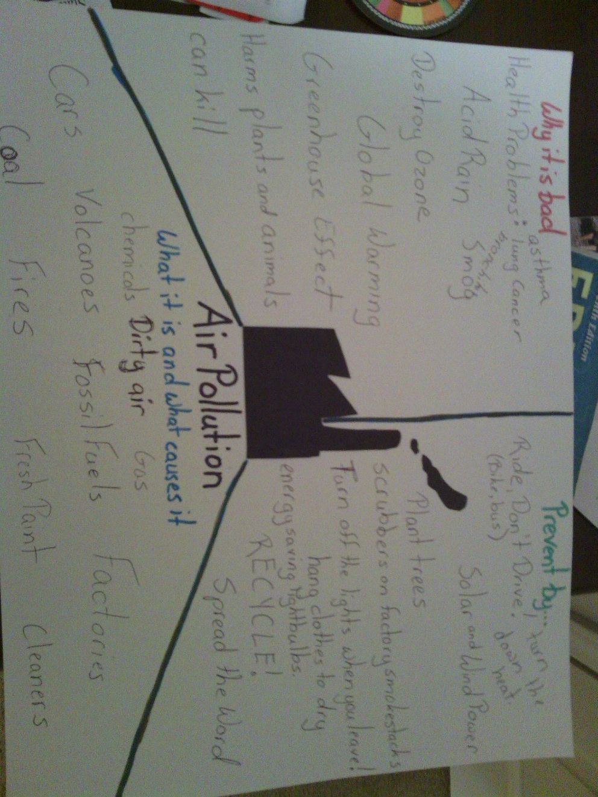

References (production piece)
Asimov, I. (1994). Why is the Air Dirty? Milwaukee: Gareth Stevens, Inc.
Baines, J. (1998). Protecting Our Planet: Keeping the Air Clean. Austin: Steck-Vaughn Co.
Busch, E., Gordon, D., & Hughes, C. D. (n.d.). Zipper's Green Tips. Retrieved from National Geographic: Kids: http://kids.nationalgeographic.com/kids/stories/spacescience/green-tips/
Unknown. (n.d.). Air Quality. Retrieved from Kids 4 Clean Air: http://www.clean-air-kids.org.uk/airquality.html
Wheeler, J., Kamstra, A., & Schaeppi, K. (1993). For the Birds: A Book About Air. Minneapolis: Abdo & Daughters.

